**Hands On Lab 1**

**Spring Basics**

### Assignment 01

A Model class “Movie” has the below properties

• movieId – String – E.g.: M001

• movieName – String – E.g.: The Firm

• movieActor – String – E.g.: Tom Cruise

• Create a spring xml configuration file to create a bean entry

for the Movie object with some sample property values

The client program should be able to display all the details of

the Movie object on the console.

Instructions:

1. Create a simple maven project.
2. Replace with the given pom.xml.
3. Edit the pom.xml using properties element or <build><plugins> element so as to have the IDE pick up the correct installed JDK version.(JDK 11). must be showing by default.
4. Create the model Movie class with appropriate getters and setters.
5. Create a class Main.java and add the following to the main method:

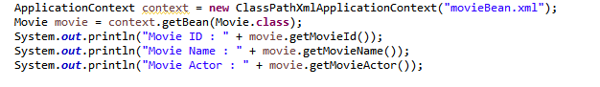

1. Run the application. Output should be as below:



